Drive Shafts and Constant Velocity Joints
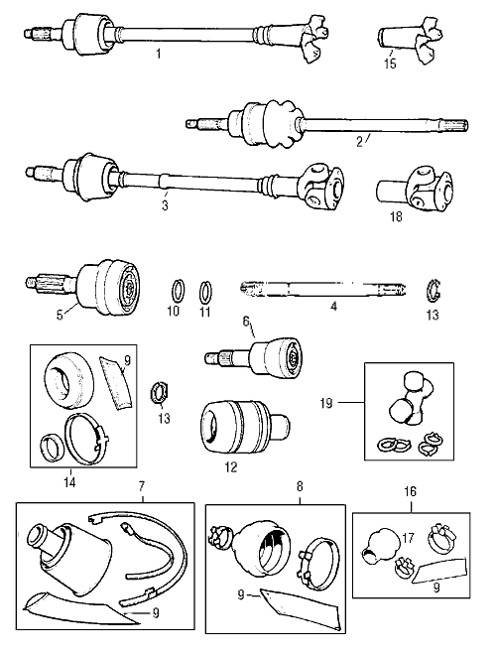
No. | Part No. | Description | Qty | Remarks
1 | 21A1760 | R/H driveshaft rubber coupling type, CWE , 11/8 axle net | 1 | 997/998 Cooper
1 | 21A1761 | L/H driveshaft......................................CWE | 1 | Minis pre discs
1 | 21A2295 | R/H driveshaft, rubber coupling type, CWE | 1 | 1275GT/'S'
1 | 21A2296 | L/H driveshaft, rubber coupling type, CWE | 1 | 1275GT/'S'
2 | GVC1104 | R/H driveshaft less inboard pot joint was 22A1961 | 1 | Drum brakes 73 on
2 | GVC1103 | L/H driveshaft less inboard pot joint was 22A1960 | 1 | Drum brakes 73 on
2 | GVC1100 | R/H driveshaft less inboard pot joint, was 22A1963 | 1 | Disc except 'S'
2 | GVC1101 | L/H driveshaft less inboard pot joint, was 22A1962 | 1 | Disc except 'S'
3 | 21A1852 | R/H driveshaft, automatic | 1 | CWE
3 | 21A1854 | L/H driveshaft, automatic | 1 | CWE
3 | 21A1857 | R/H driveshaft Hardy Spicer type, CWE | 1 | Cooper 'S'
3 | 21A1858 | L/H driveshaft Hardy Spicer type, CWE | 1 | Cooper 'S'
4 | 27H4775 | R/H shaft only, except inboard pot joint type | 1 | Upgraded material spec.
4 | 27H4776 | L/H shaft only, except inboard pot joint type | 1 | Upgraded material spec.
4 | MS1246 | R/H shaft only, inboard pot joint only all 1973 on | 1 | Upgraded material spec.
4 | MS1247 | L/H shaft only, inboard pot joint only all 1973 on | 1 | Upgraded material spec.
5 | GCV1105 | Constant Velocity Joint was 17H8600 | 2 | 1 1/8 socket
6 | GCV1013 | Outer constant velocity joint (Cooper S, late disc brakes) | 2 | 1 5/16 socket size
7 | GDG233 | Budget Gaiter Kit for GCV1105
7 | 18G9027MS | Boot kit for either type CV joint (Does not foul hubs) | 2 | Aftermarket
7 | GSV1185 | Boot kit for either type C.V. | 2 | Unipart
8 | GSV1053 | Boot kit for GCV1013 genuine | 2 | Late type
8 | GDG202 | Budget Boot kit for GCV1013
9 | AKF1457 | Grease for CV joint | A/R | In gaiter kit
10 | 37H8706 | Circlip inner, CV joint was 17H8596 | 2 | Extra or pot joint
11 | 17H8597 | Circlip outer, CV joint thick | 2
12 | GCV1102 | Inboard C.V. (pot) joint, | 2
13 | 37H8705 | Oil seal for pot joint - to shaft | 2
14 | BHM7012 | Gaiter kit for DAM667 | 2
14 | GSV1073 | Heavy duty gaiter for ADU4378 was BHM7205 (genuine) | 2
14 | GDG234 | Budget Boot kit for GCV11102
15 | 21A1696 | Flange for rubber coupling type | 2
16 | 18G9029 | Gaiter kit for 21A1696 | 2
17 | GSV1192 | Heavy duty Gaiter kit for 21A1696
17 | 21A963 | Gaiter only | 2 | As used on Hilo kit
18 | 27H7880 | Hardy Spicer sliding joint | 2 | Auto and 'S'
19 | GUJ101 | Universal joint repair kit | 2 | Auto and 'S

