Fit Hi-Lo's
Before I start, I would like to point out that this is meant as a guide to fitting Hi-Lo’s and that I or The Mini Forum take no responsibility for any injuries or breakages that may occur whilst carrying out any work on your mini. (You’re bound to draw blood at some point, it’s a mini after all!)
Front To do this you will need a cone compression tool.
Step 1.
Loosen the wheel nuts on the side you’re going to be working on.
Step 2.
From under the bonnet, undo and remove the subframe tower bolt from the bulkhead cross member (34mm socket)
Step 3.
As you can see, there are 5 parts to it. There are two bars that look the same with threads at each end and a nut on one end. There is a different thread on these on the oppostite end to the nut, on one it is coarse and the other is fine (can’t remember the thread size). The coarse threaded one is for the earlier canes and the fine threaded one is for the later cones (post 84?).Screw the bar with thread all the way down to the other bar that fits your cone thread and insert it through the subframe tower bolt hole and screw it into the cone as far as it will go.
Next take the ‘T’ shaped part and slide it over the top of the threaded bar and make sure the base is sat flush on the cross member.
Then screw the handle part onto the threaded bar. Tighten this down by h and as tight as possible, then I use a short bar around 8” long to tighten it a couple more turns. If you do this while the car is still sat on the ground, it uses the weight of the car to compress the cone so you don’t have to strain trying to compress it so far yourself.
Step 4.
Now that the cone is compressed, jack and support the car in a safe way on level ground, using axle stands where needed.
Step 5.
Remove the wheel and you’ll see a shorter version of the cone that you removed from the rear suspension tucked away in the subframe.
Step 6.
You may find it easier to remove the shock absorber and lower bump-stop from under the top suspension arm. This will give you a little more room to get the cone out, but the screw that holds the bump-stop in place can be a pain to get out, so unless you really need to, I wouldn’t bother.
Step 7.
Lift (or lever if tight) the cone upwards. Because the rubber doughnut is compressed you’ll have room above the cone to lift it and the knuckle out of its cup and free of the suspension arm.
As I said at the start, you’re bound to draw blood at some point!
Step 8.
Once the cone is out, it will look like this with a knuckle joint in one end.
Step 9.
If using the existing knuckle joints you need to remove it from the end of the cone, if you fitting new ones then leave it were it is.
Step 10.
The front Hi-Lo is slightly different from the rear – it doesn’t have the long bar part of it, but instead has a bolt with a hole drilled in the end for the knuckle joint to sit in. It still works in the same way as the rear, but is just a shorter version.
Step 11.
Put all the parts together, not forgetting to add some copper grease to the threads and wind the bolt part in as far as it goes (only hand tight though) to make the whole assembly as short as possible to make it easier to fit.
Step 12.
Pack the knuckle joint cup with grease if using the existing joint, or make sure the cup has been removed if using a new joint. Then insert the assembly into the subframe large end first and wind the bolt part back out until the Hi-Lo is sat in the rubber doughnut at the top and the knuckle cup at the bottom and re-fit the rubber dust cover.
Step 13.
Re-fit the shock absorber and rubber bumpstop if removed and re-fit the wheel. Lower the car back onto the ground and loosen then remove the cone compression tool.
Step 14.
Re-fit the subframe tower bolt and tighten to the torque setting in your workshop manual.
Again, the same steps apply to both sides at the front. It will also take a few days of trial and error before you get the ride height how you want it and level all the way round. Setting each Hi-Lo by how many threads you can see doesn’t work, and neither does using a tape measure straight after you fit them. You need to let them bed in for a few miles, then adjust each one a little at a time until it is how you want it.

Added by MiniSprocket
It would also be wise to set the working length of all trumpets to exactly the same length as the originals, this way avoiding an uneven ride hight and also give you somewhere to start from as the car will sit at the same hight as standard.
If you are realy clever you can work out how much to shorten the trumpets to achive the ride hight you want, before they are fitted.
Front
The ratio of action of lever on the front is 3:1, therefore to achieve a ride hieght adjustment on the front of 1 inch, 0.333 (1 third) inch has to be removed from the trumpet length.

1 cm höher einstellen = Schraube um 2mm drehen.
3 cm höher einstellen= Schraube um 1cm höher drehen
Tip: stelle Trompeten neben Hilos und vergleiche die Höhe.
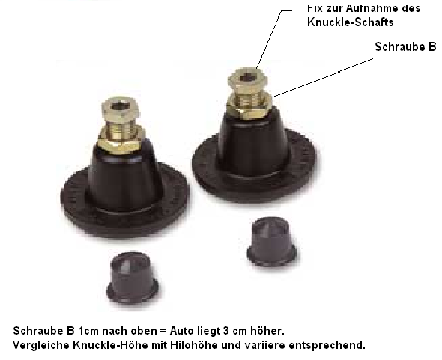

-end-

MINISPARES (2011)
SUSPENSION ONE PAIR OF ADJUSTABLE TRUMPETS HILO £45.18 inc vat
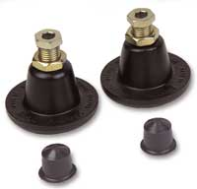 | Description  Each Hi-Lo Suspension Kit Includes one pair of Hi-Lo trumpets and nylon knuckle cups which will fit front or rear, but you will need the sleeved rods HILO-01 to enable fitment to the rears.For a car set you require 2 HILO kits plus HILO-01 kit.A complete car set is available as HILO-SET. Many people will tell you why you should consider upgrading to the original classic "Hi/Lo" suspension so I should not be bashful in giving my opinion! The best reason is they are the only RAC homologated set available which gives safety issues "a peace of mind" The adjustablility of ride heights allows you to very accurately balance the corner weight of the car. This is very important if precise handling is your objective! "It's easy to change ride heights" "It was designed years ago for Special Tuning rally programme" "It allows you to compensate for sagged rubber cones" correcting ride heights The shape of the trumpet against the cone spring helps improve handling If you need the car even lower,dispence with the locking nut which was never on the originals and shorten the main adjuster bolt 3/4" and circlip. Hexagon adjusting rods are available seperately for the original method of easier adjustment except front 1976 on where the larger subframe turret bolt was fitted hence why Keith Dodd initiated the change to spanner adjustable. The Hilo also lowers more than the budget sets available! neither does it corode and seize up like alL metal type.This alloy type is also claimed to be slightly quiter in transmitting road noise. SPANNERS REQUIRED TO ADJUST ARE 26mm AND 32mm

=======================================================================================

Hi-Los designed by Ripspeed
and made under licence by Mini Spares are the original and best adjustable height suspension trumpets for a Mini.
They have a redesigned and patented shape spring platform that works to alter the spring rate of the rubber cone spring and stabilise the ride. They have access to spray grease inside them while fitted and stop them siezing up. They also have a proper finish to stop them corroding unlike most of the cheaper copies.
All the other units including the Mini Sport Adjust-a-Ride are simply adjustable length trumpets, they do nothing to the spring rate as this feature is protected by a patent.

