Fehlzündungen – Troubleshooting Backfiring and bad ignition
Possible causes:
- The fuel injectors may be dirty.
The fix: Clean or replace fuel injectors.
- The engine may be running too hot.
The fix: Check and repair cooling system.
- The fuel pressure regulator may be operating at low pressure.
The fix: Check fuel pressure with a fuel pressure gauge. Replace fuel pressure regulator. (Generally not a DIY job)
- The ignition timing may be set wrong.
The fix: Adjust ignition timing.
- Ignition system problem.
The fix: Check and –if necessary -replace distributor cap, rotor, ignition wires and spark plugs. Measure if ignition leads to the sparks if they have a more or less equal resistance (Ohm)
- There may be a fault in the computerized engine control system: Check engine control systems with a scan tool. Test circuits and repair or replace components as required. (Generally not a DIY job)
- The fuel filter may be partially clogged.
The fix: Replace the fuel filter every 50.000 miles.
- The fuel pump may have a problem, the pump itself or the wires in the back are faulty.
- There may be a vacuum leak.Are the vacuum pipes correctly mounted? Using the "old" type of vac-pipes with the black plugs check if they are fixed too tight on the nipples.
- Are the vac-pipes correctly fixed on the
- Possible internal engine problems.
The fix: Check compression to determine engine condition.
- EGR valve may be stuck open.
The fix: Replace EGR valve.

II. The coolant temp sensor
is the black sensor located in the inlet manifold. It can be found underneath at the right side of the manifold as you stand at the front of the car.
The coolant temperature sensor works on the same principle as the air temperature sensor, where by as the temperature falls the resistance rises or vica versa. Problems arise when this sensor reads out again for the same reasons as the air sensor. This has a more dramatic effect on the fueling of the engine. If its so far out the ECU may never leave the cold start and warm up programs wich are open loop control where the signal from the oxygen sensor is almost ignored. Again this sensor will usualy read out low. A permenantly rich condition will result. This sensor is connected directly to the ECU and then the ECU provides a signal to the Temp gauge on the dash. The gauge should read not quite mid way, just a little below the white line when the engine is warm. If it reads any different then there is a problem with the engine controlling the temperature. Or the sensor is faulty. On that note it is worth while checking the plug connectors as these can suffer contact corossion. This sensor can only be acurately checked with the diagnostic and a calibrated thermometer. If there is any doubt and you are unable to have a diagnostic done then I would advise replacement but thats only if you are suffering a rich condition and the temp gauge reads below and never anywhere near the mid white line, not above as this would probibly be a cooling system fault.
Again if this sensor is faulty and causes an over rich mixture for long periods, the Oxygen sensor will usualy fail too, as discused above in the air sensor section.
It also may be worth noting that if the thermostatic control is not working correctly on the cooling system that both a hot and cold condition can result so it is in your best interest to fault find this first. For instance if the cooling system fault causes cooler engine temperatures then the ECU will see this as if the engine is still warming up and stay in cold start.
STARTING THE ENGINE DO NOT TOUCH THE ACCELERATOR PEDAL. IF EVERYTHING IS OK THEN THE ENGINE STARTS WITHOUT PRESSING THE PEDAL!

The main one that seems to cause a problem is the one on the end of the short capilary identified with white, from the back of the inlet manifold to the fuel trap. Located on this port on the back of the inlet manifold, again identified with white.
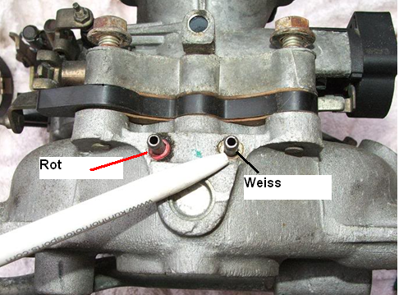

PICTURE BELOW.
This hose can cause ignition problems if it is not oK. I do not know the English words for this. But see red arrow
Schlauch von der Kurbelwellen-Gehäuseentlüftung am Zwischenradgehäuse.
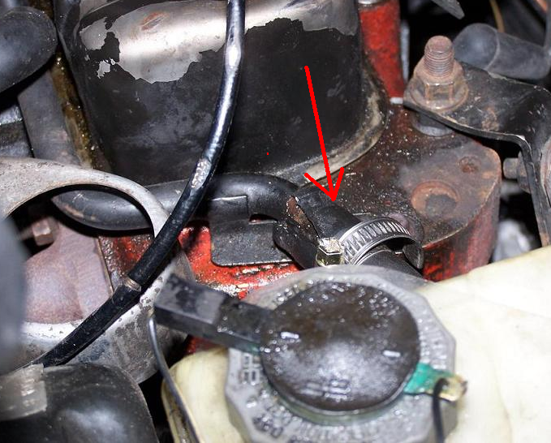

Check if Accelerator Cable is correctly fixed. See picture below
